**JavaFX – Installation**

Open Eclipse.

1. Perform an update –go to Help > Check for Updates. Update to the latest SDK as shown below. Accept license, run update, restart Eclipse.

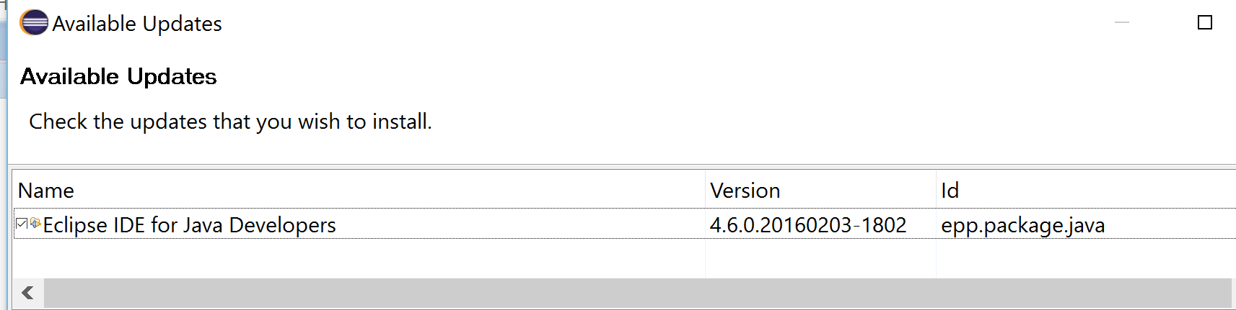

1. Next go to Help > Install New Software… Then click on Add.. and at the pop up Add Repository dialog box, enter FX for Name and for Location include the following url (as shown below)

<http://download.eclipse.org/efxclipse/updates-released/2.3.0/site>

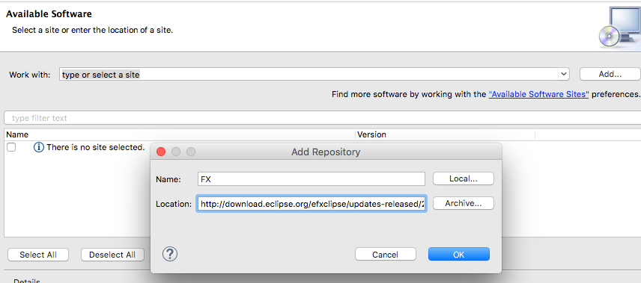

Click OK to accept entries. Then in your Available Software screen, check all feature add ons.

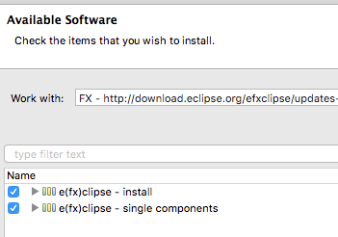

Keep the default check boxes checked at the Details portion of your screen and press Next. Press Next again at the Install Details screen and accept the EULA agreement and then click on Finish to install the software. Restart Eclipse when prompted.